|  |  |  |
| --- | --- | --- |
| American University of SharjahCollege of Engineering Dept of Computer Science & Engg  P. O. Box 26666  Sharjah, UAE |  | Instructors: Dr. Tamer [Shanableh](javascript:detailw('detail.asp?ID=@00010457')) **Lab Instructor:** Ms. Praveena Kolli  **Office** EB2-126  **Phone**: 971-6-5152352  **e-mail**: [pkolli@aus.edu](mailto:pkolli@aus.edu)  **Semester**: Spring 2023 |

**CMP354L -** [**Mobile Application Development**](https://banner.aus.edu/axp3b21h/owa/bwckschd.p_disp_detail_sched?term_in=201410&crn_in=11136)

**Lab9**

**Topics:**

* Firebase authentication
* Cloud DB

**Exercise 1:**

Develop an app that uses cloud Firebase to save course records in the respective logins. The App has the following activities,

1. **Login page** -> user can sign up and login with email and password. On the successful login go to Courses activity.
2. **Course activity**-> User can add, view and delete courses. It also calculates and displays the GPA.
   1. *Add*: Enter Course code, name, credits, and letter grade to save/edit the record in firebase. Use spinner for letter grade.
   2. *View*: Enter course code. Then View button listener retrieves the data and displays in the widgets.
   3. *Delete*: Enter course code. Then Delete button listener deletes the course from firebase.
   4. *GPA*: Calculate GPA and display it along with the courses saved in an alert dialogue. Alert Dialogue code is provided.

GPA calculating Formula, https://gpacalculator.net/how-to-calculate-gpa/

Alert Dialogue Code:

AlertDialog alertDialog = new AlertDialog.Builder(Courses.this).create();  
alertDialog.setTitle("Alert");  
alertDialog.setMessage(("Alert Message"););  
alertDialog.setButton(AlertDialog.*BUTTON_NEUTRAL*, "OK",  
 new DialogInterface.OnClickListener() {  
 public void onClick(DialogInterface dialog, int which) {  
 dialog.dismiss();  
 }  
 });  
alertDialog.show();

Course Activity Design XML:

*<?*xml version="1.0" encoding="utf-8"*?>*<TableLayout xmlns:android="http://schemas.android.com/apk/res/android"  
 android:layout_width="match_parent"  
 android:layout_height="match_parent">  
  
 <TableRow  
 android:layout_width="match_parent"  
 android:layout_height="match_parent"  
 android:layout_margin="20dp">  
  
 <LinearLayout  
 android:layout_width="match_parent"  
 android:layout_height="match_parent"  
 android:orientation="horizontal">  
  
 <TextView  
 android:id="@+id/textView"  
 android:layout_width="wrap_content"  
 android:layout_height="wrap_content"  
 android:layout_marginRight="30dp"  
 android:layout_weight="1"  
 android:text="Course Code" />  
  
 <EditText  
 android:id="@+id/editTextcrsCode"  
 android:layout_width="wrap_content"  
 android:layout_height="wrap_content"  
 android:layout_weight="1"  
 android:ems="10"  
 android:inputType="textPersonName" />  
  
  
 </LinearLayout>  
 </TableRow>  
  
 <TableRow  
 android:layout_width="match_parent"  
 android:layout_height="match_parent"  
 android:layout_margin="20dp">  
  
 <LinearLayout  
 android:layout_width="match_parent"  
 android:layout_height="match_parent"  
 android:orientation="horizontal">  
  
 <TextView  
 android:id="@+id/textView2"  
 android:layout_width="wrap_content"  
 android:layout_height="wrap_content"  
 android:layout_marginRight="30dp"  
 android:layout_weight="1"  
 android:text="Course Name" />  
  
 <EditText  
 android:id="@+id/editTextTextCrsName"  
 android:layout_width="wrap_content"  
 android:layout_height="wrap_content"  
 android:layout_weight="1"  
 android:ems="10"  
 android:inputType="textPersonName"  
 />  
 </LinearLayout>  
 </TableRow>  
  
 <TableRow  
 android:layout_width="match_parent"  
 android:layout_height="match_parent"  
 android:layout_margin="20dp">  
  
 <LinearLayout  
 android:layout_width="match_parent"  
 android:layout_height="match_parent"  
 android:orientation="horizontal">  
  
 <TextView  
 android:id="@+id/textView3"  
 android:layout_width="wrap_content"  
 android:layout_height="wrap_content"  
 android:layout_marginRight="50dp"  
 android:layout_weight="1"  
 android:text="Credits" />  
  
 <EditText  
 android:id="@+id/editTextTextCrsCredits"  
 android:layout_width="wrap_content"  
 android:layout_height="wrap_content"  
 android:layout_weight="1"  
 android:ems="10"  
 android:inputType="number" />  
  
 </LinearLayout>  
 </TableRow>  
 <TableRow  
 android:layout_width="match_parent"  
 android:layout_height="match_parent"  
 android:layout_margin="20dp">  
  
 <LinearLayout  
 android:layout_width="match_parent"  
 android:layout_height="match_parent"  
 android:orientation="horizontal">  
  
 <TextView  
 android:id="@+id/textView4"  
 android:layout_width="wrap_content"  
 android:layout_height="wrap_content"  
 android:layout_marginRight="70dp"  
  
 android:text="Grade" />  
  
 <Spinner  
 android:id="@+id/spinner"  
 android:layout_weight="1"  
 android:layout_width="match_parent"  
 android:layout_height="wrap_content" />  
 </LinearLayout>  
 </TableRow>  
 <TableRow  
 android:layout_width="match_parent"  
 android:layout_height="match_parent"  
 android:padding="30dp">  
  
 <LinearLayout  
 android:layout_width="match_parent"  
 android:layout_height="match_parent"  
 android:orientation="horizontal">  
  
 <Button  
 android:id="@+id/button5"  
 android:layout_width="wrap_content"  
 android:layout_height="wrap_content"  
 android:layout_weight="1"  
 android:onClick="onClick_addbtn"  
 android:text="Add" />  
  
 <Button  
 android:id="@+id/button4"  
 android:layout_width="wrap_content"  
 android:layout_height="wrap_content"  
 android:layout_weight="1"  
 android:onClick="onClick_btnGetDocIntoObject"  
 android:text="View" />  
  
 <Button  
 android:id="@+id/button3"  
 android:layout_width="wrap_content"  
 android:layout_height="wrap_content"  
 android:layout_weight="1"  
 android:onClick="onClick_deleteCrs"  
 android:text="Delete" />  
  
 <Button  
 android:id="@+id/button2"  
 android:layout_width="wrap_content"  
 android:layout_height="wrap_content"  
 android:layout_weight="1"  
 android:onClick="onClick_btngetalldecuments"  
 android:text="GPA" />  
 </LinearLayout>  
 </TableRow>  
</TableLayout>

Submit: java codes, screenshots of the running app and APK.

**MainActivity.java:**

package com.example.cmp354_lab9;  
  
import androidx.annotation.NonNull;  
import androidx.appcompat.app.AppCompatActivity;  
  
import android.content.Intent;  
import android.os.Bundle;  
import android.util.Log;  
import android.view.View;  
import android.widget.EditText;  
import android.widget.Toast;  
  
import com.google.android.gms.tasks.OnCompleteListener;  
import com.google.android.gms.tasks.Task;  
import com.google.firebase.auth.AuthResult;  
import com.google.firebase.auth.FirebaseAuth;  
import com.google.firebase.auth.FirebaseUser;  
import com.google.firebase.firestore.DocumentReference;  
import com.google.firebase.firestore.FirebaseFirestore;  
  
//Main source: https://firebase.google.com/docs/auth/android/start#java_5  
  
public class MainActivity extends AppCompatActivity {  
  
  
  
 String TAG = "CMP354:";  
 EditText et_username, et_password;  
 private FirebaseAuth mAuth;   
  
 @Override  
 protected void onCreate(Bundle savedInstanceState)  
 {  
 super.onCreate(savedInstanceState);  
 setContentView(R.layout.*activity_main*);  
  
 //authentication  
 mAuth = FirebaseAuth.*getInstance*();  
  
 et_password = findViewById(R.id.*et_password*);  
 et_username = findViewById(R.id.*et_usename*);  
 }  
  
 public void onClick_btn(View v)  
 {  
 if (et_password.getText().toString().isEmpty()) return;  
  
 if (v.getId()==R.id.*btn_login*) {  
  
 //Create a new signIn method which takes in an email address and password,  
 // validates them, and then signs a user in with the signInWithEmailAndPassword method.  
 mAuth.signInWithEmailAndPassword(et_username.getText().toString(), et_password.getText().toString())  
 .addOnCompleteListener(this, new OnCompleteListener<AuthResult>() {  
 @Override  
 public void onComplete(@NonNull Task<AuthResult> task) {  
 if (task.isSuccessful()) {  
 // Sign in success, update UI with the signed-in user's information  
 Log.*d*(TAG, "signInWithEmail:success");  
 FirebaseUser user = mAuth.getCurrentUser();  
 Intent i = new Intent(getApplicationContext(), CoursesActivity.class);  
 i.putExtra("username", user.getEmail());  
 startActivity(i);  
 } else {  
 // If sign in fails, display a message to the user.  
 Log.*w*(TAG, "signInWithEmail:failure", task.getException());  
 Toast.*makeText*(getApplicationContext(), "Authentication failed.",  
 Toast.*LENGTH_SHORT*).show();  
 }  
 }  
 });  
 }  
 //----------------------------------------  
 //Create a new signIn method which takes in an email address and password,  
 // validates them, and then signs a user in with the signInWithEmailAndPassword method.  
 else if (v.getId()==R.id.*btn_signup*)  
 {  
 mAuth.createUserWithEmailAndPassword(et_username.getText().toString(), et_password.getText().toString())  
 .addOnCompleteListener(this, new OnCompleteListener<AuthResult>() {  
 @Override  
 public void onComplete(@NonNull Task<AuthResult> task) {  
 if (task.isSuccessful()) {  
 // Sign in success, update UI with the signed-in user's information  
 Toast.*makeText*(getApplicationContext(), "Create User With Email : success\nPlease login",  
 Toast.*LENGTH_SHORT*).show();  
 FirebaseUser user = mAuth.getCurrentUser();  
  
 } else {  
 // If sign in fails, display a message to the user.  
 Log.*w*(TAG, "createUserWithEmail:failure", task.getException());  
 Toast.*makeText*(getApplicationContext(), "Authentication failed.",  
 Toast.*LENGTH_SHORT*).show();  
 }  
 }  
 });  
 }  
 }  
  
  
}

**CoursesActivity.java:**

package com.example.cmp354_lab9;  
  
import androidx.annotation.NonNull;  
import androidx.appcompat.app.AlertDialog;  
import androidx.appcompat.app.AppCompatActivity;  
  
import android.content.DialogInterface;  
import android.os.Bundle;  
import android.util.Log;  
import android.view.View;  
import android.widget.ArrayAdapter;  
import android.widget.EditText;  
import android.widget.Spinner;  
import android.widget.Toast;  
  
import com.google.android.gms.tasks.OnCompleteListener;  
import com.google.android.gms.tasks.OnFailureListener;  
import com.google.android.gms.tasks.OnSuccessListener;  
import com.google.android.gms.tasks.Task;  
import com.google.firebase.firestore.CollectionReference;  
import com.google.firebase.firestore.DocumentReference;  
import com.google.firebase.firestore.DocumentSnapshot;  
import com.google.firebase.firestore.FirebaseFirestore;  
import com.google.firebase.firestore.QueryDocumentSnapshot;  
import com.google.firebase.firestore.QuerySnapshot;  
  
import java.text.DecimalFormat;  
import java.util.HashMap;  
import java.util.Map;  
  
public class CoursesActivity extends AppCompatActivity {  
  
 private EditText et_code;  
 private EditText et_name;  
 private EditText et_credits;  
 private Spinner spinner;  
 ArrayAdapter<CharSequence> adapter;  
  
 static FirebaseFirestore *db*;  
  
  
  
 @Override  
 protected void onCreate(Bundle savedInstanceState) {  
 super.onCreate(savedInstanceState);  
 setContentView(R.layout.*activity_courses*);  
  
 et_code = findViewById(R.id.*editTextcrsCode*);  
 et_name = findViewById(R.id.*editTextTextCrsName*);  
 et_credits = findViewById(R.id.*editTextTextCrsCredits*);  
 spinner = findViewById(R.id.*spinner*);  
  
  
  
 adapter = ArrayAdapter.*createFromResource*(  
 this, R.array.*spinner*, android.R.layout.*simple_spinner_item*);  
 adapter.setDropDownViewResource(android.R.layout.*simple_spinner_dropdown_item*);  
 spinner.setAdapter(adapter);  
  
  
 *db* = FirebaseFirestore.*getInstance*();  
  
 }  
  
 public void onClick_addbtn(View v)  
 {  
 CollectionReference courses = *db*.collection("courses");  
  
 Map<String, Object> course = new HashMap<>();  
 course.put("code", et_code.getText().toString());  
 course.put("name", et_name.getText().toString());  
 course.put("credits", et_credits.getText().toString());  
 course.put("grade", spinner.getSelectedItem().toString());  
  
 courses.document(et_code.getText().toString()).set(course);  
  
  
 clearET();  
 }  
  
 public void onClick_btnGetDocIntoObject(View v){  
 DocumentReference docRef = *db*.collection("courses").document(et_code.getText().toString());  
 docRef.get().addOnSuccessListener(new OnSuccessListener<DocumentSnapshot>() {  
 @Override  
 public void onSuccess(DocumentSnapshot documentSnapshot) {  
 Course course = documentSnapshot.toObject(Course.class);  
  
 et_code.setText(course.getCode());  
 et_name.setText(course.getName());  
 et_credits.setText(course.getCredits());  
 spinner.setSelection(adapter.getPosition(course.getGrade()));  
 }  
 });  
 }  
  
 public void onClick_btngetalldocuments(View v){  
 *db*.collection("courses")  
 .get()  
 .addOnCompleteListener(new OnCompleteListener<QuerySnapshot>() {  
 @Override  
 public void onComplete(@NonNull Task<QuerySnapshot> task) {  
 double grade=0, totalcredits = 0;  
  
 if (task.isSuccessful()) {  
 String s = "";  
 for (QueryDocumentSnapshot document : task.getResult()) {  
 Course course = document.toObject(Course.class);  
 double g=0;  
  
 if(course.getGrade().equals("A")){  
 g=4.0d;  
 }  
 else if(course.getGrade().equals("B")){  
 g=3.0d;  
 }  
 else if(course.getGrade().equals("C")){  
 g=2.0d;  
 }  
 else if(course.getGrade().equals("D")){  
 g=1.0d;  
 }  
  
  
 grade += (g*(Integer.*parseInt*(course.getCredits())));  
 totalcredits += (Integer.*parseInt*(course.getCredits()));  
 s += document.toObject(Course.class) + "\n\n";  
  
 }  
  
 DecimalFormat df=new DecimalFormat("0.00");  
  
 s+="GPA= " + df.format(grade/totalcredits) + "\n";  
  
 AlertDialog alertDialog = new AlertDialog.Builder(CoursesActivity.this).create();  
 alertDialog.setTitle("Alert");  
 alertDialog.setMessage(s);  
 alertDialog.setButton(AlertDialog.*BUTTON_NEUTRAL*, "OK",  
 new DialogInterface.OnClickListener() {  
 public void onClick(DialogInterface dialog, int which) {  
 dialog.dismiss();  
 }  
 });  
 alertDialog.show();  
  
  
 } else {  
 Log.*d*("CMP354:", "Error getting documents: ", task.getException());  
 }  
 }  
 });  
 }  
  
 public void onClick_deleteaCourse(View v)  
 {  
 if (et_code.getText().toString().isEmpty()) return;  
  
 *db*.collection("courses").document(et_code.getText().toString())  
 .delete()  
 .addOnSuccessListener(new OnSuccessListener<Void>() {  
 @Override  
 public void onSuccess(Void aVoid) {  
 Toast.*makeText*(getApplicationContext(),  
 et_code.getText().toString() + " successfully deleted!",  
 Toast.*LENGTH_SHORT*).show();  
 }  
 })  
 .addOnFailureListener(new OnFailureListener() {  
 @Override  
 public void onFailure(@NonNull Exception e) {  
 Toast.*makeText*(getApplicationContext(),  
 "Error deleting document",  
 Toast.*LENGTH_SHORT*).show();  
 }  
 });  
 clearET();  
 }  
  
 void clearET(){  
 et_code.setText("");  
 et_name.setText("");  
 et_credits.setText("");  
 spinner.setSelection(0);  
 }  
}

**Screenshots:**

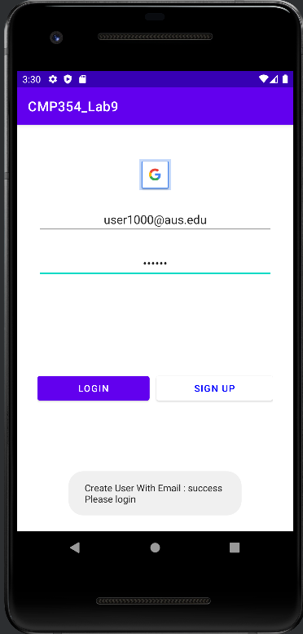

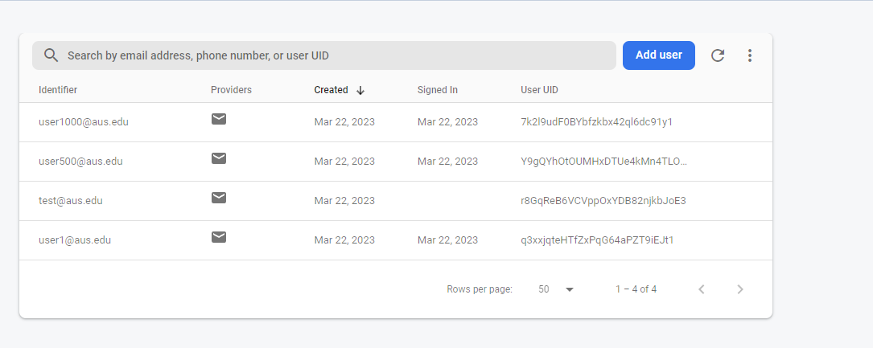

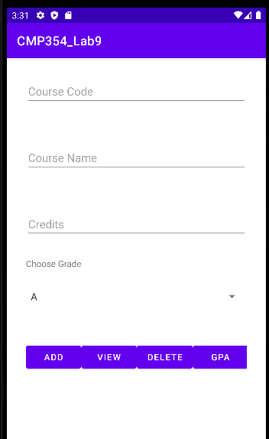

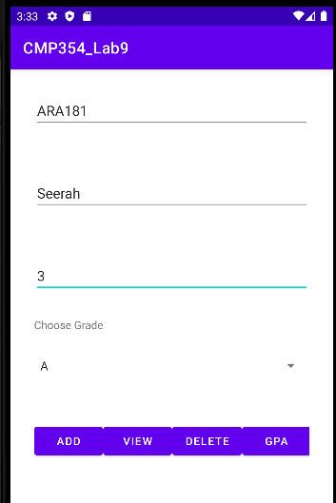

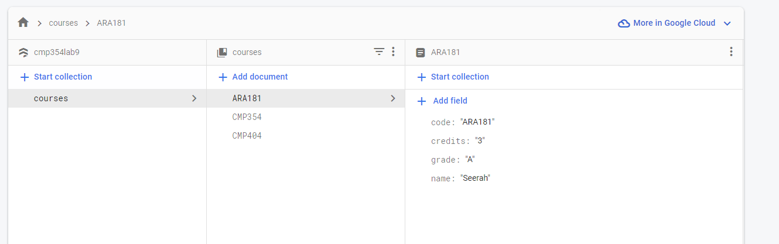

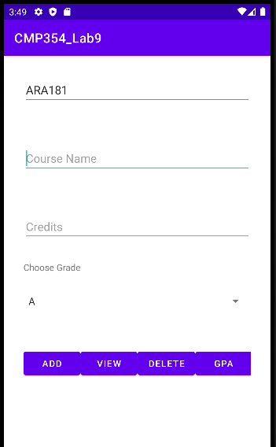

After clicking view:

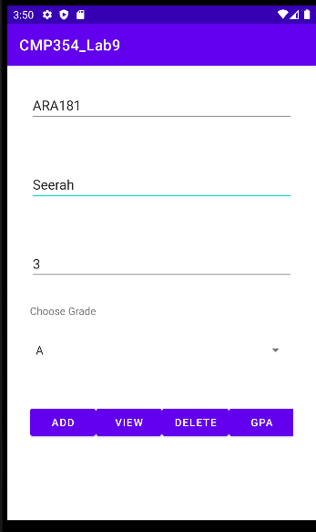

After clicking delete:

